**3025 – Assignment 2**

**Group 6 :-** Rohan yadav - C0773871

Shahrukh Padaniya - C0769542

Swapnil Sevak - C0777195

**Read the materials on pp. 85-90, Exploring Beaglebone, 2nd Edition.**

**Perform the following commands and show the outputs. What’s the meaning of each command?**

**1. cp /lib/systemd/system/cron.service /lib/systemd/system/sleep.service**

Description:

It will copy contain of cron service file to sleep service file but before i have check that sleep.service file is no existed using:

systemctl list-unit-files | grep sleep

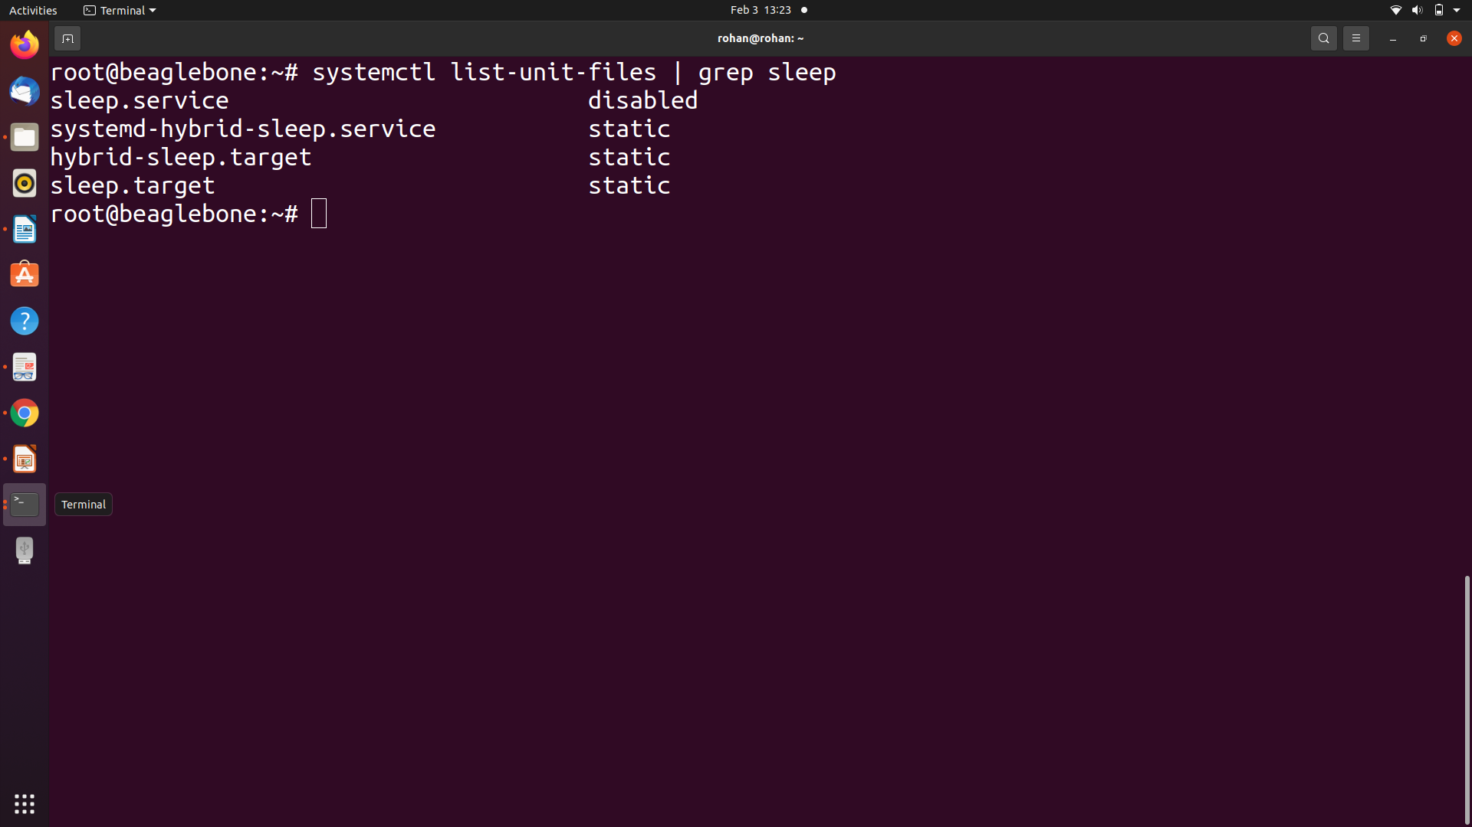

So, it will create new sleep.service file which has same functionality of cron service.

Use of cron Service:

The Linux cron daemon (named after Chronos, the Greek god of time) is a highly

configurable utility for scheduling tasks to be performed at specific times and

dates. It is typically used for system administration tasks, such as backing up

data, clearing temporary files, rotating log files, updating package repositories,

or building software packages during off-peak times.

**2. vi /lib/systemd/system/sleep.service**

Description:

This command will open vim terminal to view, insert or edit sleep.service file

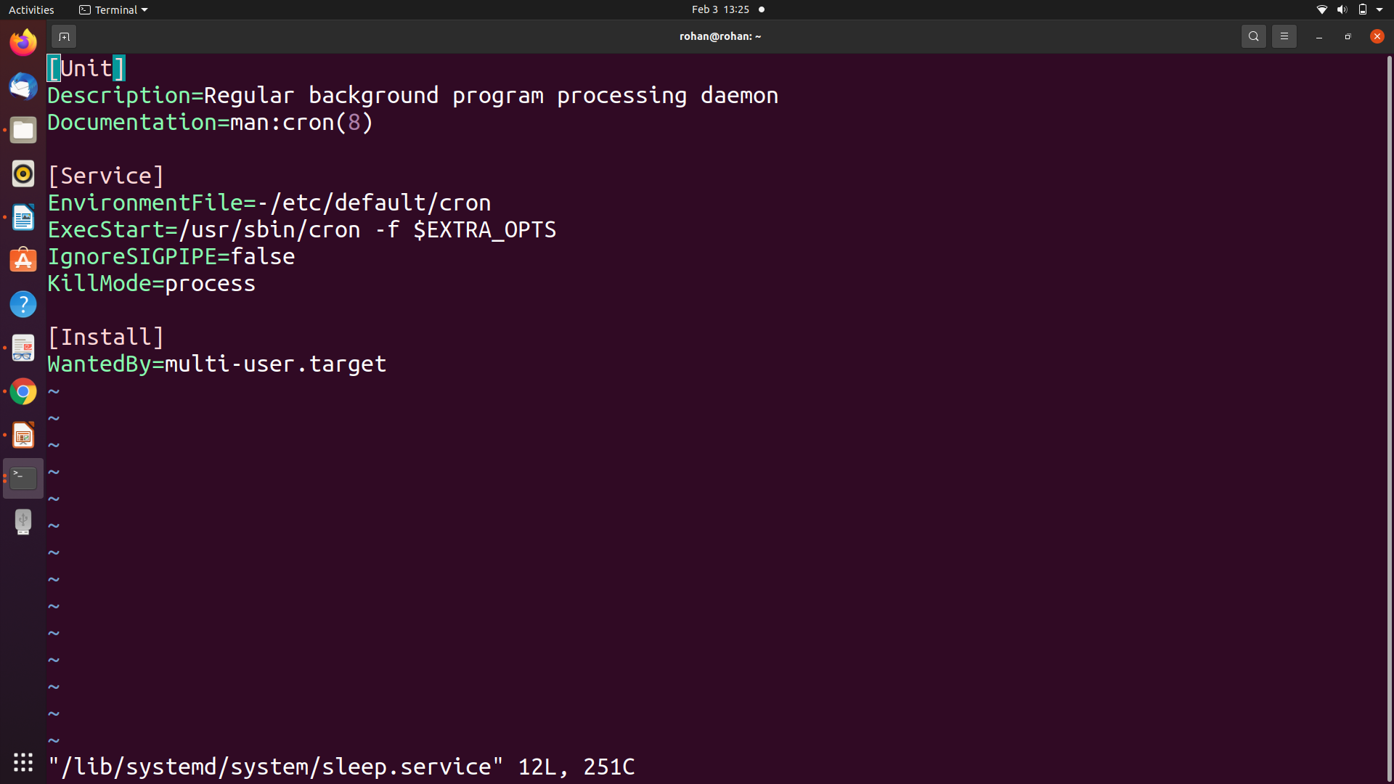

**3. systemctl enable sleep.service**

This command will enable sleep service and create symlink of sleep.service file into targeted directory.

Basically symlink is shortcut file in linux system it act as reference to target.

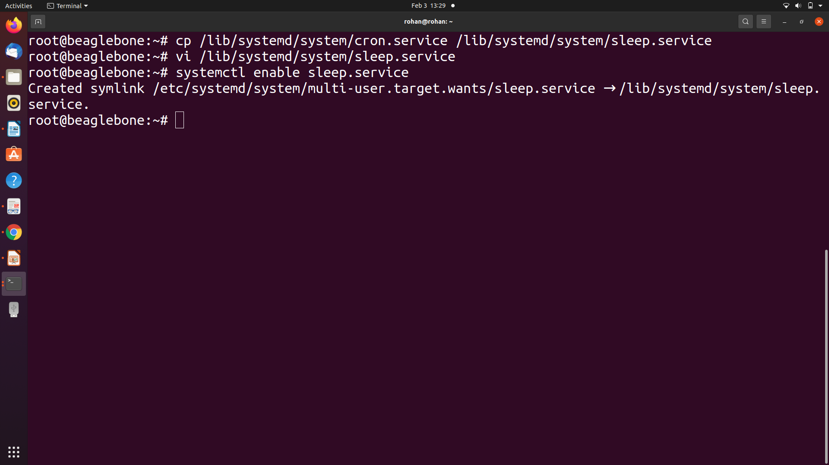

**4. systemctl start sleep.service**

Description:

This command will start service of sleep.service.

**5. systemctl status sleep.service**

Description:

This command will show details of sleep srvice which is currently running.

Here i have to stop first cron service (command: systemctl stop cron.service)

which is identical to service as both cant be run together. After this configuration sleep.service will be successfully activated.

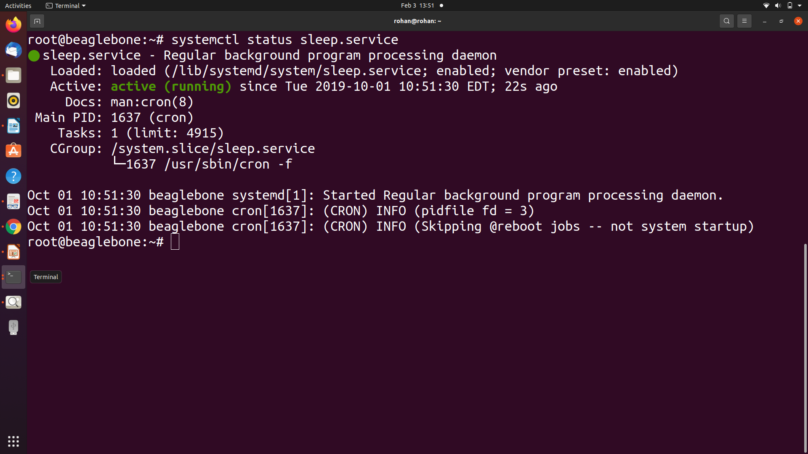

**6. systemctl stop sleep.service; systemctl disable sleep.service**

Description:

This command will first stop sleep.service and then disable it.

